# Capstone Project

## Brian Chan

## 5/8/2020

1. Introduction
   1. Background

Hong Kong is a city and special administrative region of China in the Eastern Pearl River Delta by the South China Sea with over 7.4 million people with various nationalities in a 1.104-square-kilometer territory , making Hong Kong one of the most densely populated places in the world. Besides the fact that Hong Kong is a small place with many people, there are also a variety of restaurants in Hong Kong.

* 1. Problem

There are around 16,000 restaurants in Hong Kong in 2019, competitions between restaurants have been increasing from seasons to seasons. This report aims to help people explore different possibilities and take a better decision when it comes to opening a restaurant. In order for a restaurant to be successful, data including the density of restaurants, the population density around the location were gathered.

* 1. Interest

The data and the results in this project can be interested by and beneficial to an individual who is trying to start up a business which involves the food industry. Other than that, multi national organizations in the food industry can also be interested in the data and results of this project due to the fact that this project suggests the best location of a restaurant.

1. Data Description
   1. Data Sources

This project used data gathered from Wikipedia, information such as region names in Hong Kong and the population of Hong Kong in different districts. This project also used Four-square API as its prime data gathering source as it has a database of millions of places, especially their places API which provides the ability to perform location search, location sharing and details about a business.

* 1. Data

Based on criteria listed above, the following data will be utilized in our analysis:

* The number of restaurants within the certain radius of each borough using FourSqaure API
* The net income per person in each district (<https://www.statistics.gov.hk/pub/B11303012019AN19B0100.pdf>)
* The population and the population density of the district
* The latitude and longitude of the district (<https://www.mapcoordinates.net/en>)

However, the data gathered was manually input due to the format given online, therefore data including districts, regions, population of districts, population density, latitude, longitude and net income of districts was entered in to an excel file.

1. Methodology & Analysis

The following steps have to be performed in order to find the most optimal location for setting up a restaurant after the preparing and cleaning the data.

The following is an example of the main data frame:

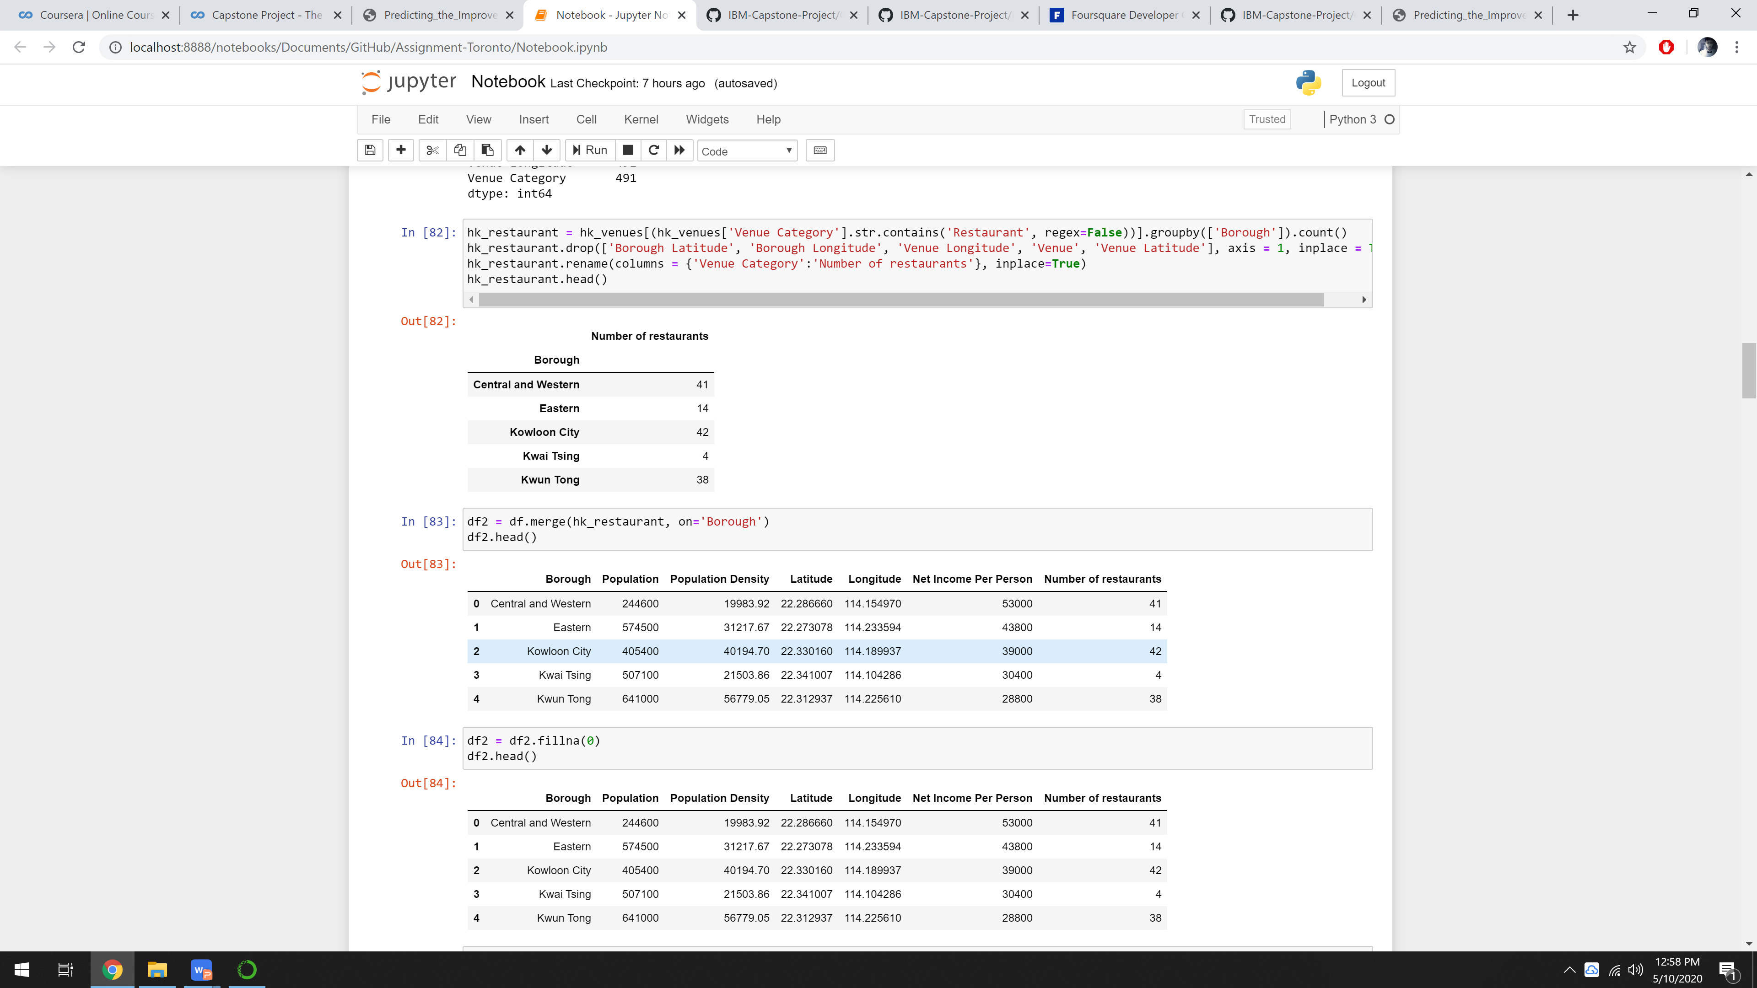

Figure 2.1 Main Data frame

An exploratory analysis will be applied to visualize the different borough on the map, then bar charts will also be shown about different values such as population in boroughs, restaurants in boroughs and income per person in borough. The values of the data frame may be reduced or replaced by more relatable data, and finally perform cluster analysis to find the best borough with data features.

* 1. Exploratory Data Analysis

The following map is to visualize each boroughs in Hong Kong.

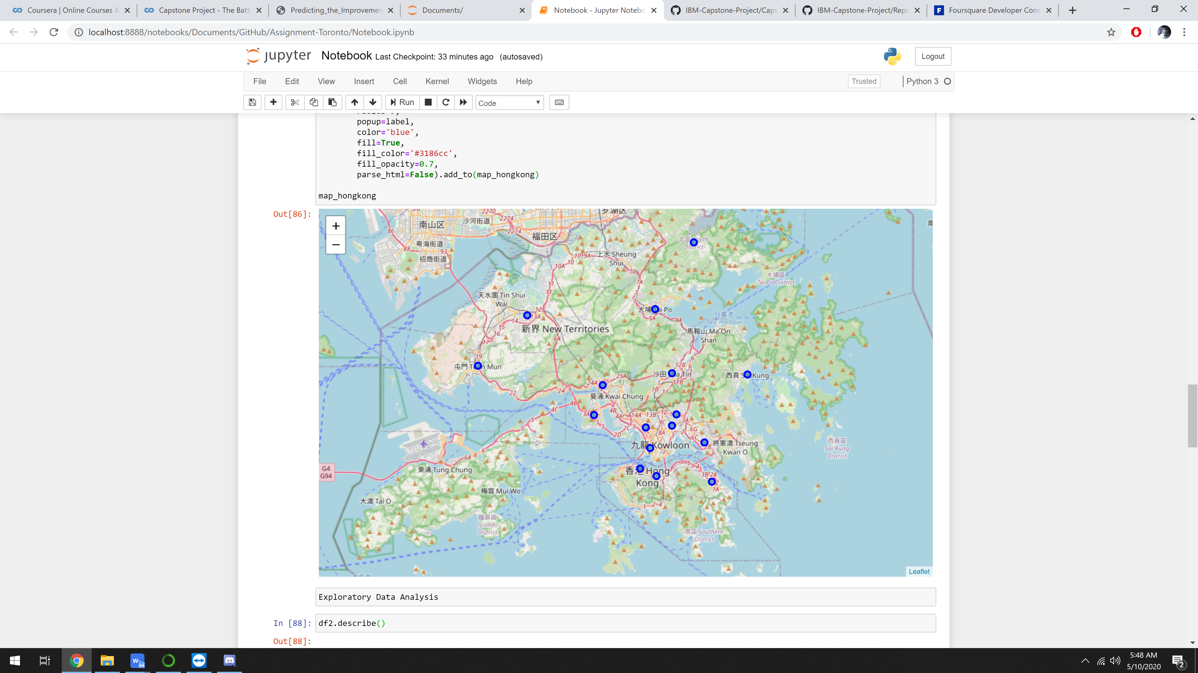

Figure 3.1 The map of Hong Kong with centers of the boroughs

The following charts were visualized with respect to the boroughs.

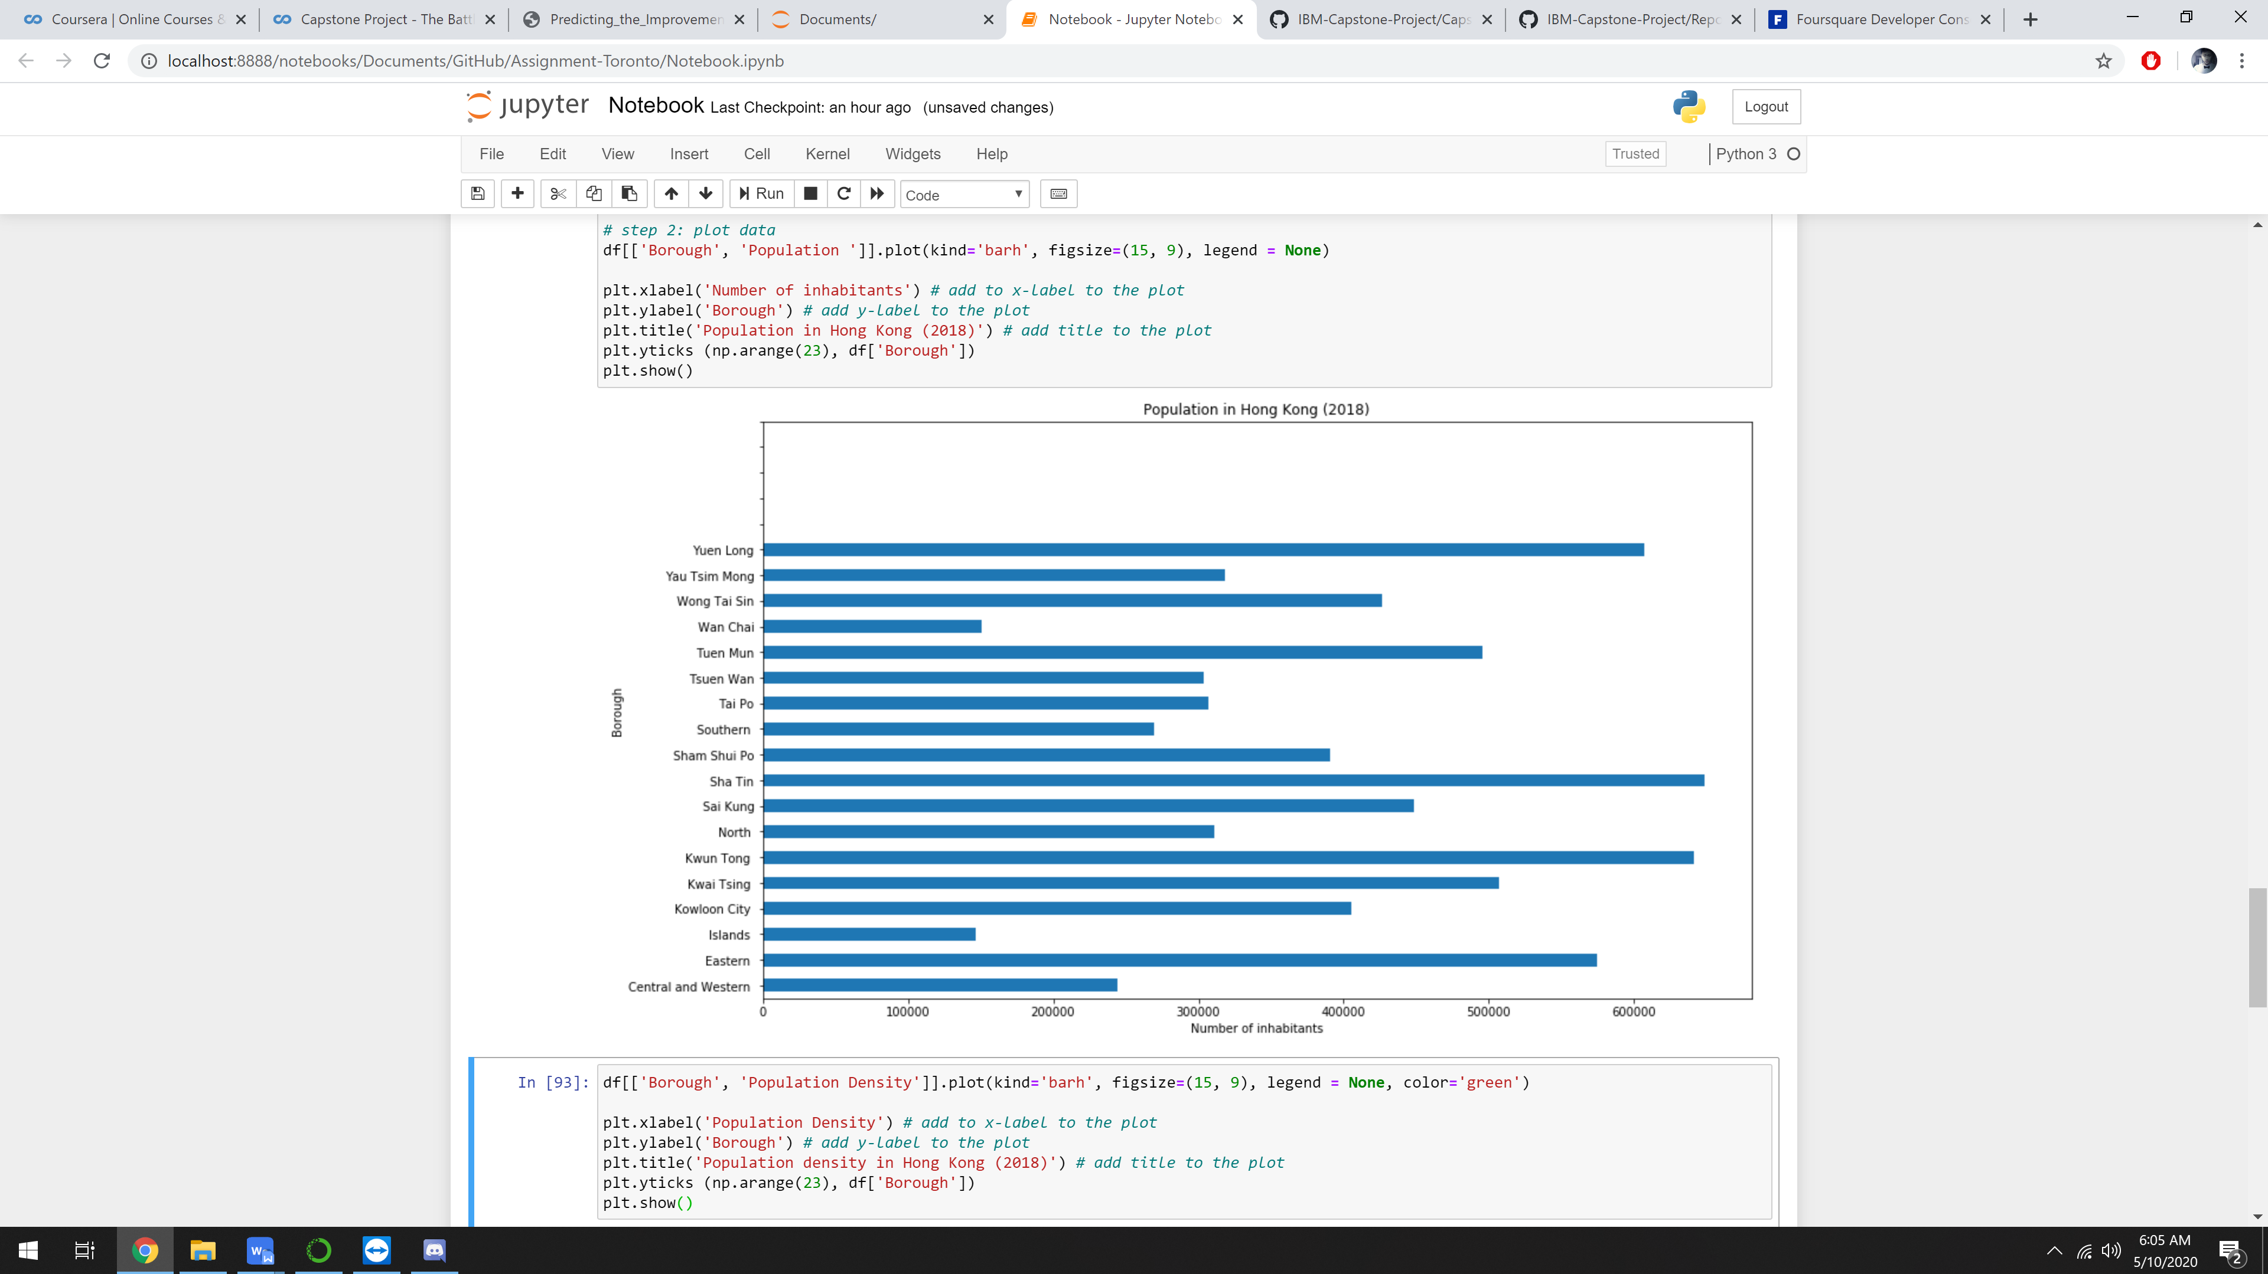

Figure 3.2 Population in Hong Kong

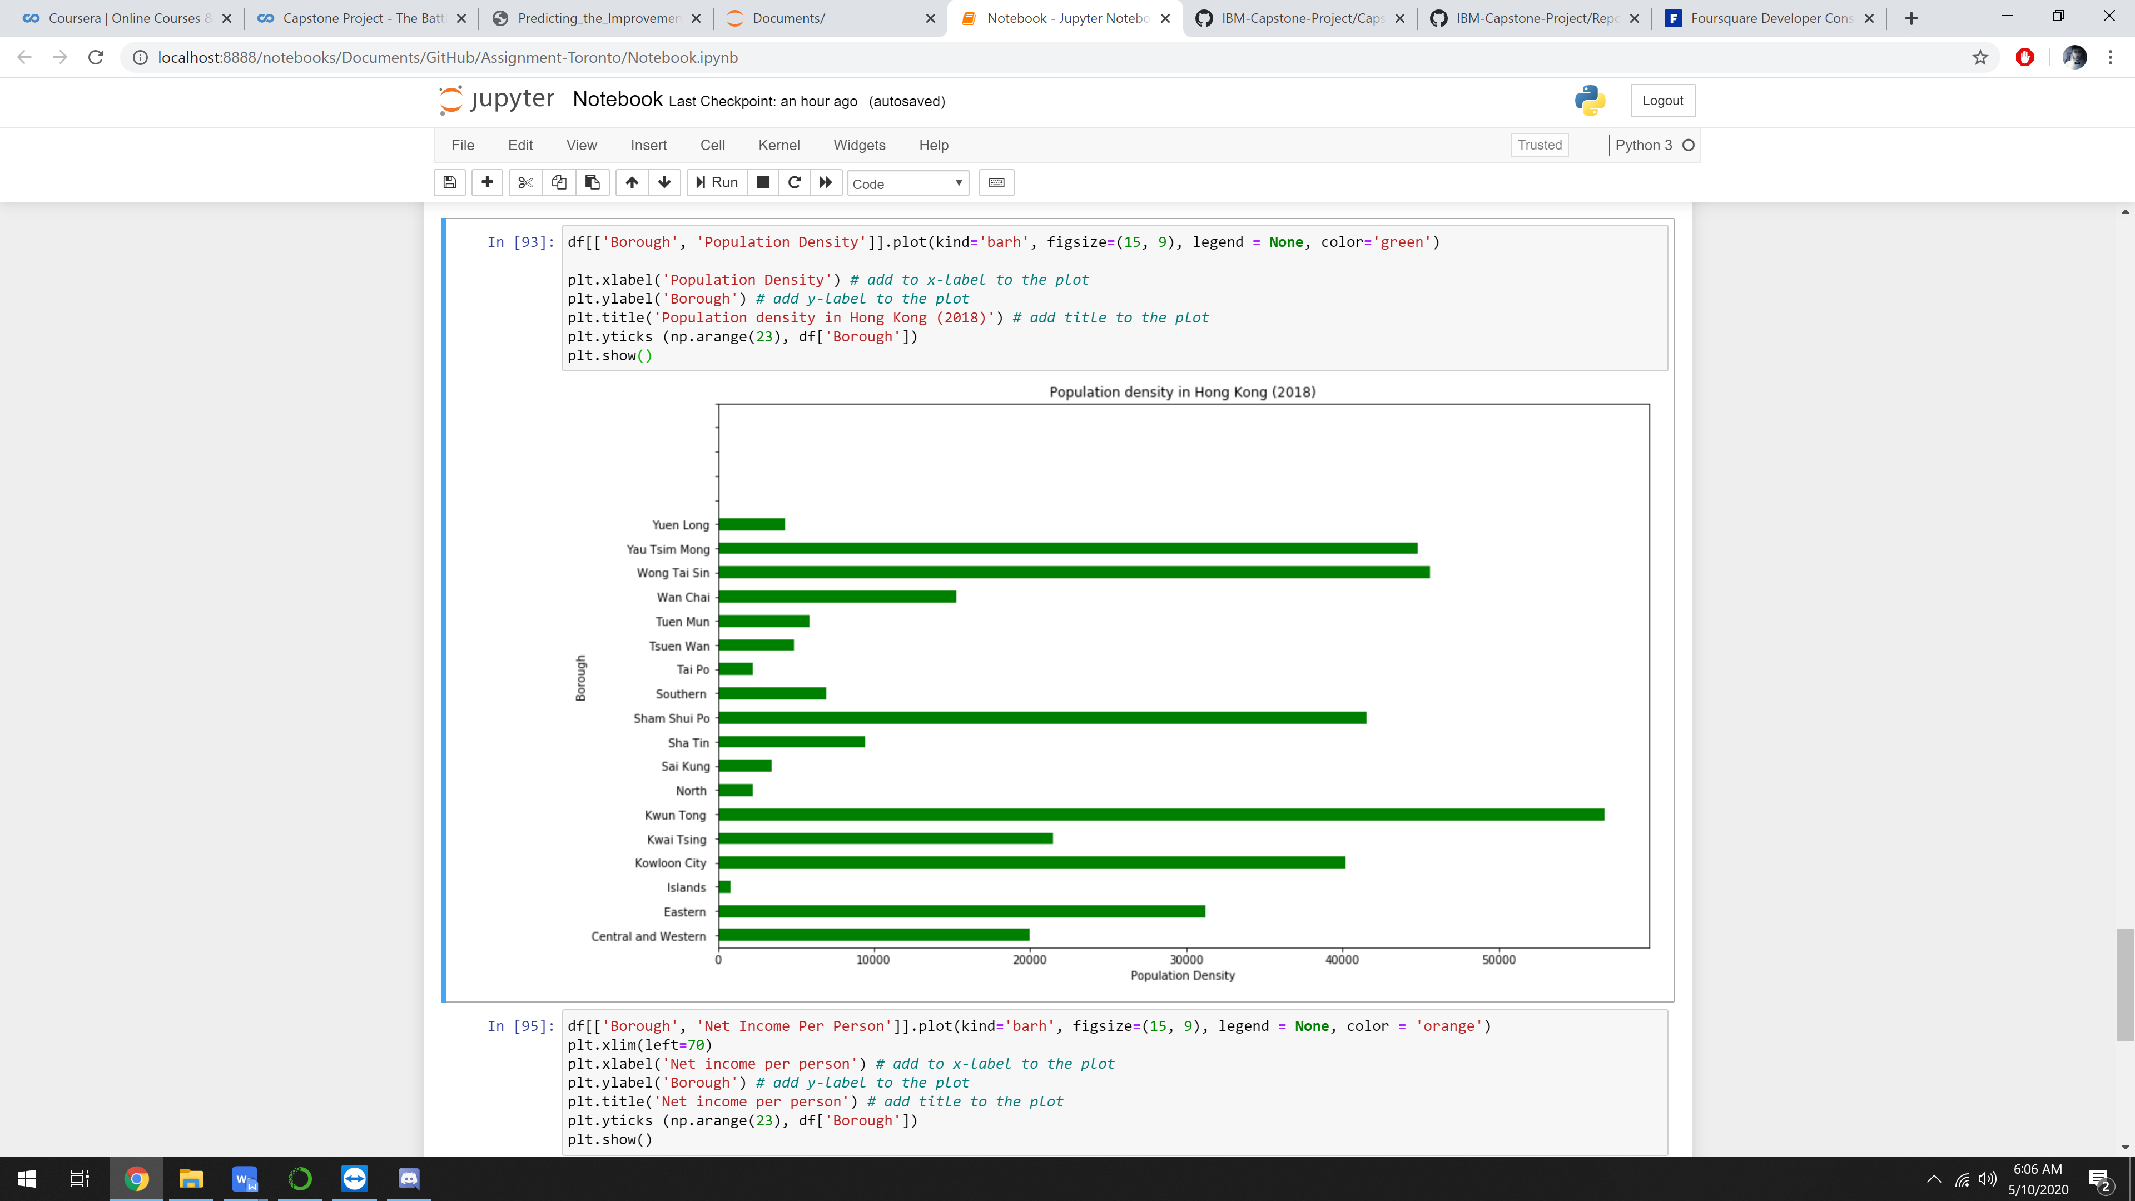

Figure 3.3 Population Density in Hong Kong

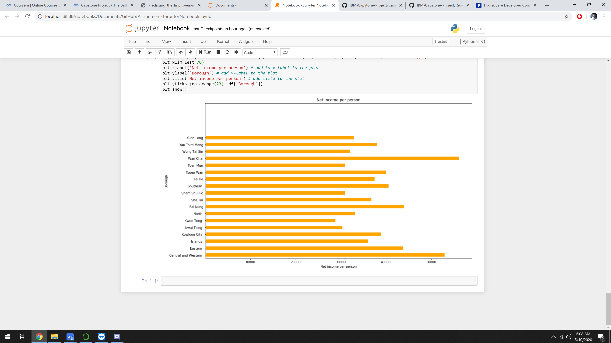

Figure 3.4 Net income per person in Hong Kong

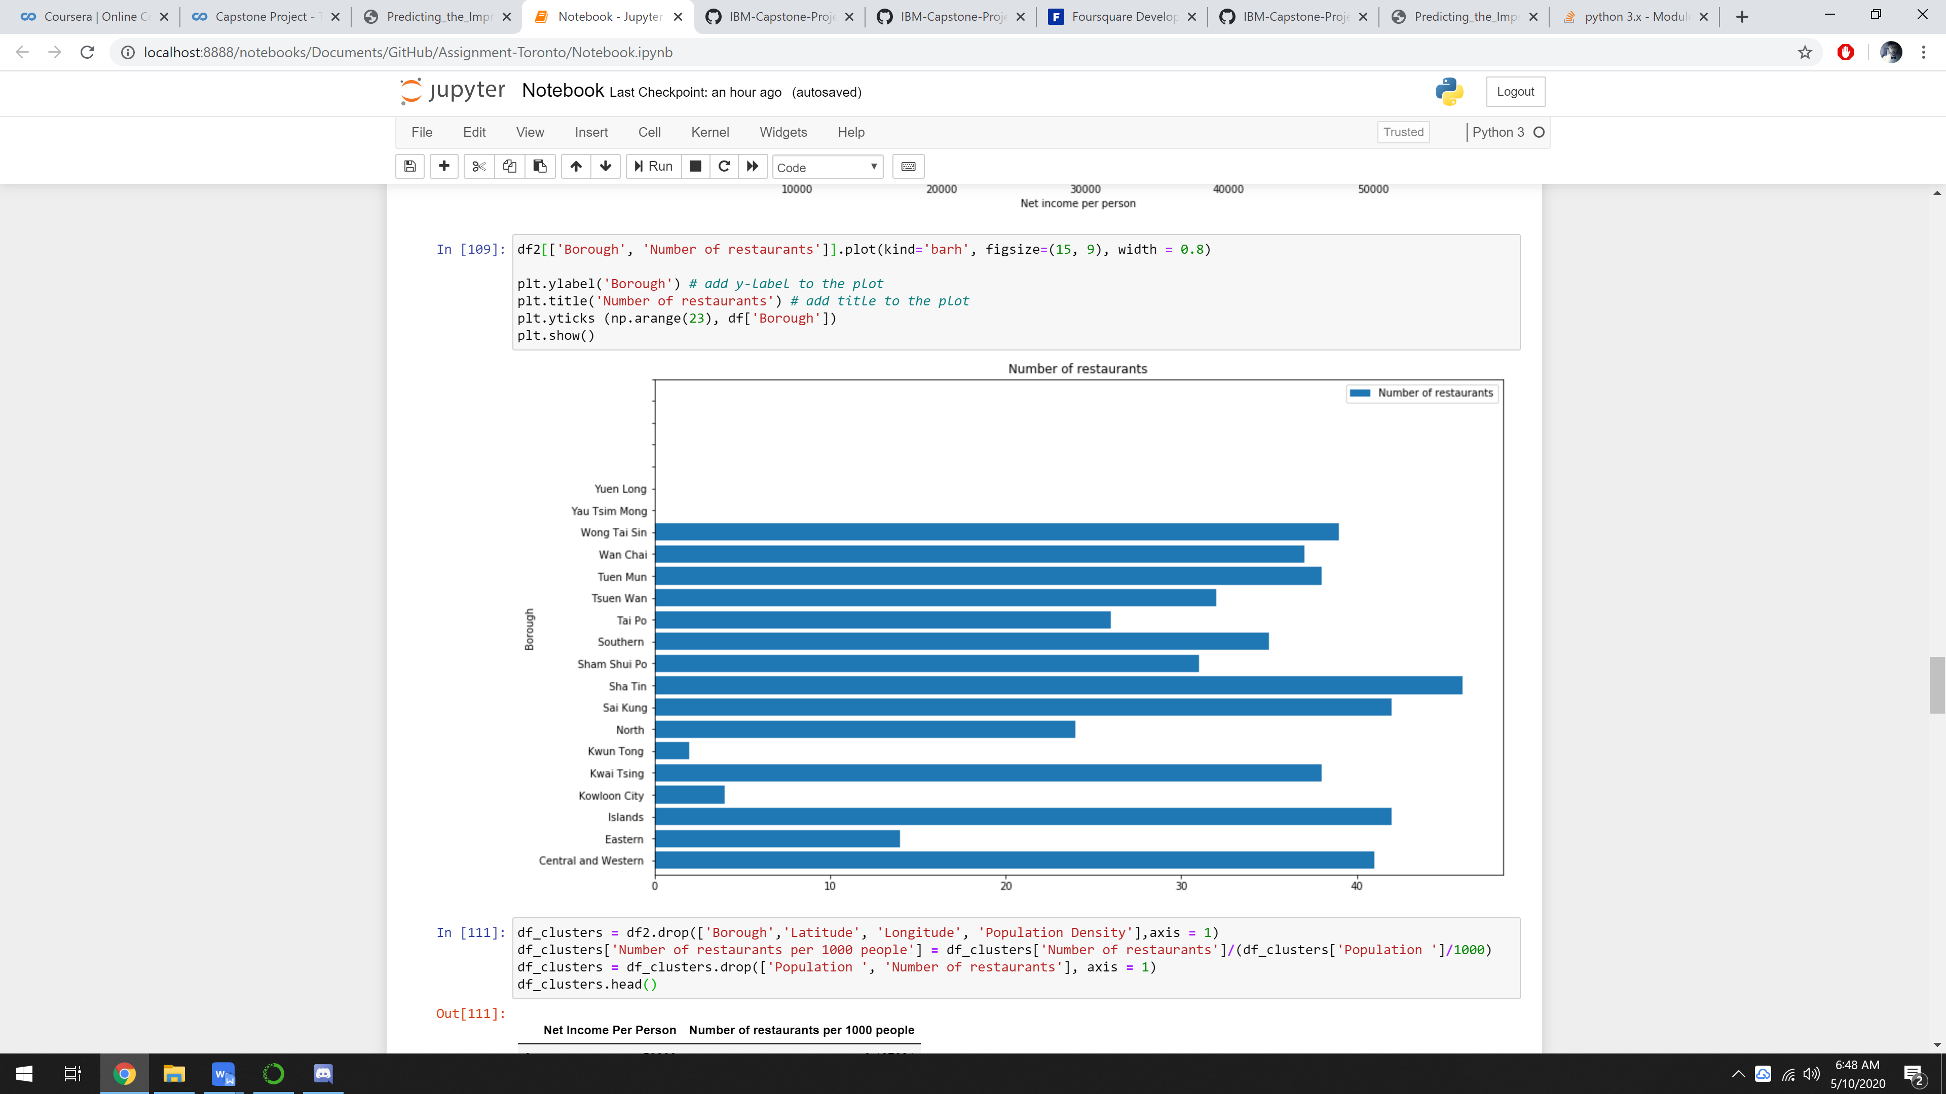

Figure 3.5 Number of Restaurants in Hong Kong

* 1. Cluster Analysis

In order to identify groups (clusters) with similar characteristics, we applied the unsupervised learning method to our data, namely K-Means algorithm. Instead of the main data frame, we will be using just number of restaurants per 1000 people and net income per person.

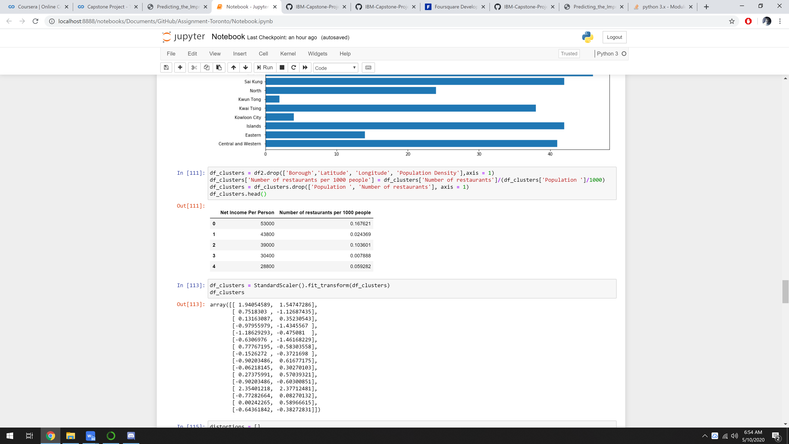

Figure 3.6 Modified data frame

In order to obtain the optimal number of clusters, the Elbow method is used:

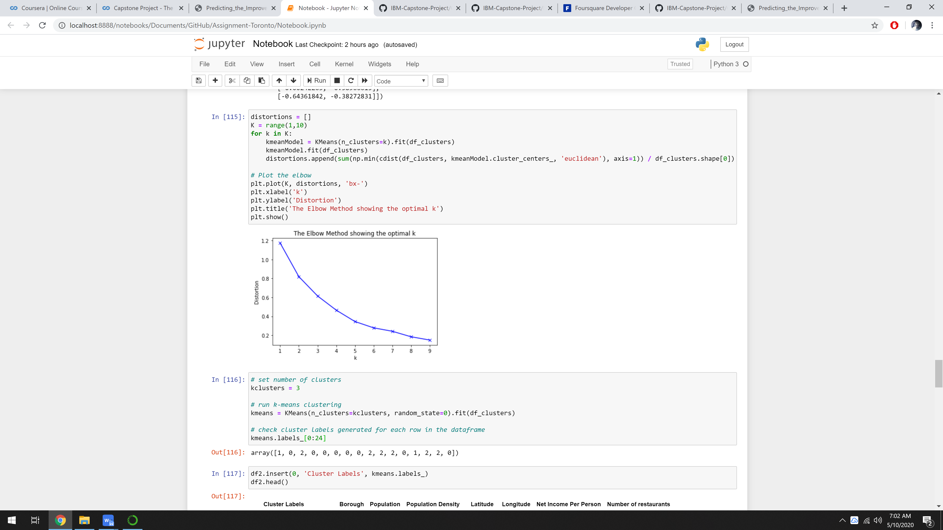

Figure 3.7 The Elbow method showing the optimal number of clusters

As seen on the graph above, the clusters of 2 and 3 can be considered the best choices. However, in this report 3 clusters will be used.

Based on clustering results, a map was created to illustrate where the colors are associated with clusters and radius of the Circle marker is proportional to a number of restaurants per 1000 people in each borough.

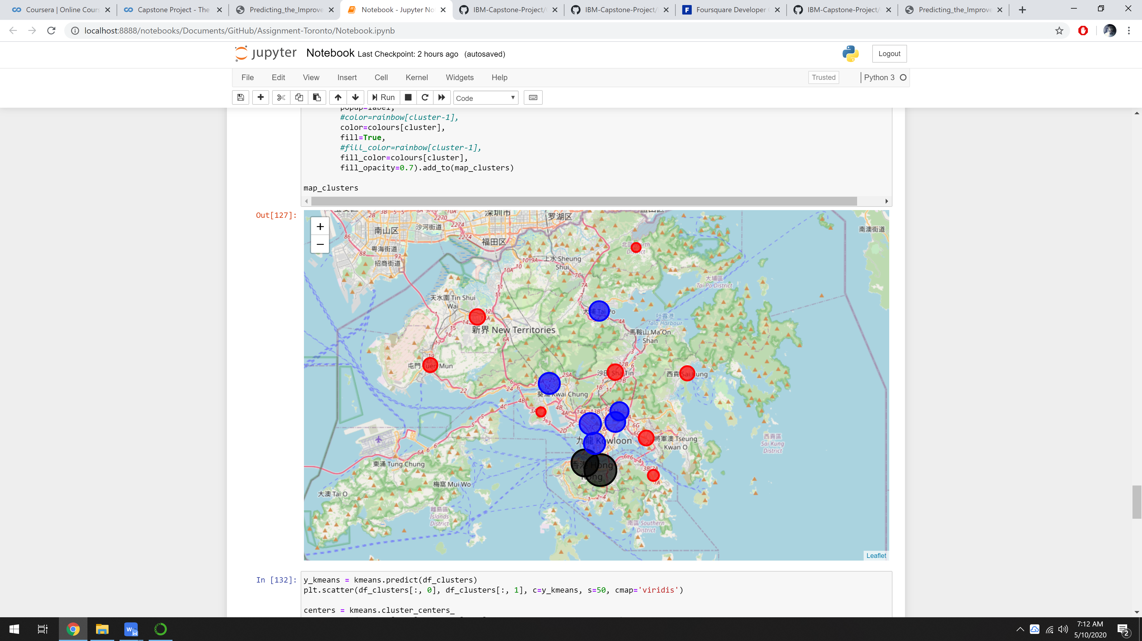

Figure 3.8 The map of Hong Kong with clustered boroughs

As you can see above, there is the two largest clusters (black circle).

The following also contains scatter plots of the normalized data, and the grey circles represent the center of each clusters.

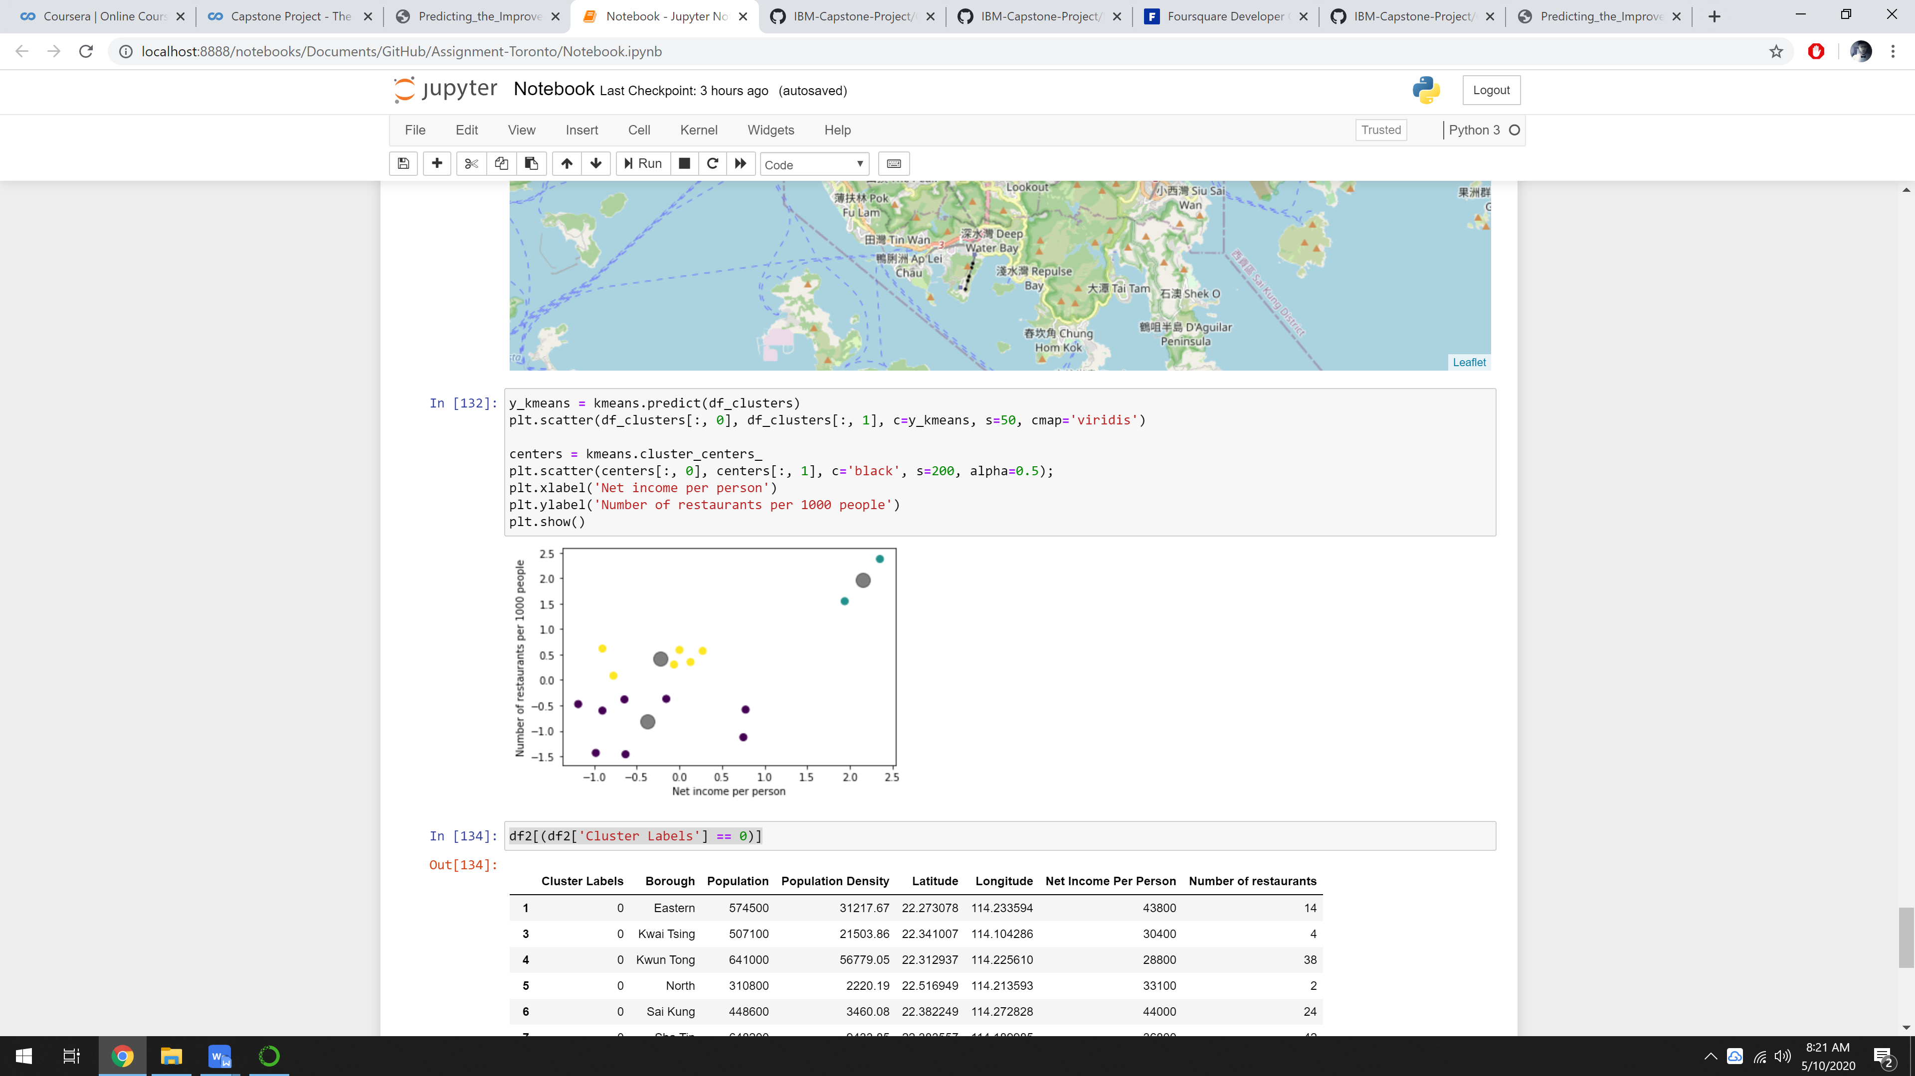

Figure 3.9 Scatter plot of clustered boroughs

As the scatter pot shown, there is an outlier (borough) has a high concentration of restaurants and also with a high net income per person. With the information from above, the outlier boroughs are the Wan Chai and Central & Western cluster.

1. Results & Discussion

During the analysis, three clusters were defined. To sum up there is one cluster with two borough which is the Wan Chai borough and Central and Western borough, are the boroughs with the highest level of competitions, as there are many other restaurants in these two boroughs compared to other, leading to a high risk investment when it comes to setting up a restaurant in those two boroughs. However, based on the income per person data, it also showed that those two boroughs have a significantly high average income compared to other boroughs, which also means that people in the two boroughs are able to spend more statistically.

On the other hand, the blue colored clusters have an medium level of restaurants plus a medium income per person, meaning there will be not as high competition compared to the two boroughs (Black Circle). Therefore, it will make clusters with boroughs Tsuen Wan, Wong Tai Sin, Sham Shui Po, Kowloon City and Yau Tsim Mong ideal to set up restaurants.

This project can be done better by considering other values such as parking places around the location, locations within the clusters and places with the most visits on average. Foursquare doesn't represent the full picture, since many venues are not on the list. For that reason, another maps could be utilized such as Google map or Openstreet map.  
Boroughs have too complex geometry, thus defining the closest venues within the certain radius brings additional error to our analysis.

1. Conclusion

To conclude, the basic data analysis was performed to identify the most optimal boroughs for the placement of the beer restaurant in the city of Stuttgart. During the analysis, several important statistical features of the boroughs were explored and visualized. Furthermore, clustering helped to highlight the group of optimal areas. Finally, Stuttgart Sud and Stuttgart Nord were chosen as the most attractive options for the further analysis.